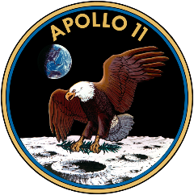
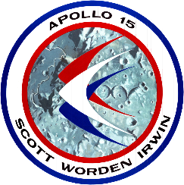
Mission Patch Design Challenge
Space missions are known for their eye-catching mission patches.
To support Space Park Leicester’s mission, we are inviting you to help design our Mission Patch. The winning designs will receive stickers of their Mission Patch and our artist will use them as inspiration for the finalised patch.
To enter, draw your patch design and write a few sentences explaining why you chose each element.

Submit your designs via Email: Outreach@Space-Park.co.uk or on
X: @SpaceParkLeic using #SpacePatchLeicester.

